Use Case Specification

DMT/RM01/TMP

|  |  |
| --- | --- |
| Project Code | PRJ_MakeMyJourneyUserRegForm_001 |
| Project Name | MakeMyJourneyUserRegForm |

|  |  |  |
| --- | --- | --- |
| Prepared/Modified by | Role | Date of Preparation |
|  |  |  |
| Reviewed by | Role | Date of Review |
|  |  |  |
| Approved by | Role | Date of Approval |
|  |  |  |
| Circulation List |  | Version Number of the template:1.1 |
| Version Number | 1.1 |  |

<<Customer>> REVIEW HISTORY

<<Customer comments on the Use case along with the signed off is tracked here>>

|  |  |  |  |  |  |  |
| --- | --- | --- | --- | --- | --- | --- |
| Version | 1.0 |  |  |  |  |  |
| Date | <<Date of Review>> |  |  |  |  |  |
| Reviewed by | << Reviewer Name>> |  |  |  |  |  |
| Reviewed UI Specification doc | << Whether UI Specification doc is reviewed >> |  |  |  |  |  |
| All Open Queries/issues closed | << Whether all the open queries and issues resolved>> |  |  |  |  |  |
| Agreement on Assumptions | <<Whether all the assumptions have been agreed upon by the customer>> |  |  |  |  |  |
| Sign Off | <<Signature>> |  |  |  |  |  |

Disclaimer:

The scope of the project ‘**LEAVE MANAGEMENT SYSTEM**’ is restricted to the contents of this signed off use case.

TABLE OF CONTENTS

1. Use Case Name: Login to the Leave Management System 5

2. Actor(s) 5

3. Preconditions 5

4. Flow of Events 5

4.1 Basic Flow 5

4.2 Alternative Flows 5

4.2.1 Alternate Flow 1: successful login to uas on second attempt 5

4.2.2 Alternate Flow 2 : Login to the LMS using Apply for Courses option 6

4.2.3 Alternate Flow 3 : Login to the LMS and user Apply for Leaves option and fill correct details second time 6

Exception Flow 1: Exceeded Login Attempts 6

Exception Flow 2: Web Server Down 6

Exception Flow 3: Database Connectivity Error 6

Exception Flow 4: Network Connectivity Error 7

5. Post Conditions 7

6. Special Requirements 8

Performance 8

Availability 8

User Interface 8

Security 8

7. Extension Points 8

Extension in Alternate Flow 1: 8

Extension in Alternate Flow x: 8

8. Business Rules 8

9. Diagrams 9

Use Case Diagram for 9

10. Scenarios 10

Success Scenarios 10

Failure Scenarios 10

11. Issues 10

12. UI Specifications 10

13. Inter System Dependencies 10

14. Integration with an already existing System of the <<Customer>> 10

15. Assumptions 11

1. Use Case Name: Login to the Leave Management System

**Use Case ID:**  LMS.UserSignUp_001

**Brief Description:** This Use Case describes the process by which User Sign Up to the Make My Journey Portal for Booking various types of travel tickects

1. Actor(s)
2. User
3. Preconditions
4. User has opened [**http://www.makemyjourney.co.in**](http://www.makemyjourney.co.in)link through a internet browser.
5. User has selected **Sign Up** link from the Home page.
6. User on clicking on **Sign Up** link he gets navigated to register page & a Sign Up form appears.
7. Flow of Events

* 4.1 Basic Flow

Name: Successful Sign Up to the Make My Journey User Registeration Form and user is able to do a successful Sign Up.

1. User clicks on the Sign up link on the Make My Journey home page.
2. The system displays **Make My Journey User Registration Form**  page
3. User enters **Username**
4. User Clicks on **Check Availabilty**
5. User selects a **Security Question.**
6. User enters his answer in  **Your Answer** field.
7. User enters **First Name.**
8. User enters **Last Name.**
9. User selects **Gender.**
10. User enters **Date of Birth.**
11. User enters **Email ID.**
12. User enters **Mobile No**
13. User clicks on the **Submit** button.
14. The system validates **Username, First Name, Last Name and all the mandatory fields.**
15. The system generates a message window to re-confirm user’s **email id** and **mobile no**.
16. User checks **email id** and **mobile no**. and clicks on **“Ok”**.
17. The system generates a message window with the **“Thank you”** message confirming the user’s registration.
    1. Alternative Flows
       1. Alternate Flow 1:

* Name: successful Sign Up to Make My Journey User Registeration Form after rejecting the USername entered by the User AND USER Successfully Signs Up.

1. User clicks on the **Sign Up** link on the Make My Journey home page
2. The system displays **Make My Journey User Registeration Form** page
3. User enters **Username.**
4. User Clicks on **Check Availabilty.**
5. The system generates a message window saying **“User already Registered...Please choose a different User Name”**
6. The step 3 of Basic flow is followed.

* + 1. Alternate Flow 2 :
* Name: Login to the Make My Journey User Registeration Form and Submits and fill correct details second time

1. User clicks on the **Sign Up** link on the Make My Journey home page
2. The system displays **Make My Journey User Registeration Form** page
3. User enters **Username.**
4. User clicks on the Sign up link on the Make My Journey home page.
5. The system displays **Make My Journey User Registration Form**  page
6. User enters **Username**
7. User Clicks on **Check Availabilty**
8. User selects a **Security Question.**
9. User forgets to enter his answer in  **Your Answer** field.
10. User enters **First Name.**
11. User enters **Last Name.**
12. User selects **Gender.**
13. User enters **Date of Birth.**
14. User enters **Email ID.**
15. User forgets to enter **Mobile No**
16. User clicks on the **Submit** button.
17. The system validates **Username, First Name, Last Name and all the mandatory fields.**
18. The system validation fails and System Prompts the user to enter all the mandatory fields.
19. User enters the mandatory fields.
20. User clicks on **submit** button.
21. The step 14 of Basic flow is followed.

* Exception Flow 1:
* name: Web Server Down

1. User clicks on the **Sign up** link on the **Make My Journey** home page
2. The system displays an error message regarding web server unavailability problem

* Exception Flow 3:
* Name: Database Connectivity Error

1. User clicks on the Sign up link on the Make My Journey home page.
2. The system displays **Make My Journey User Registration Form**  page
3. User enters **Username**
4. User Clicks on **Check Availabilty**
5. User selects a **Security Question.**
6. User enters his answer in  **Your Answer** field.
7. User enters **First Name.**
8. User enters **Last Name.**
9. User selects **Gender.**
10. User enters **Date of Birth.**
11. User enters **Email ID.**
12. User enters **Mobile No**
13. User clicks on the **Submit** button.
14. The system validates **Username, First Name, Last Name and all the mandatory fields.**
15. The system displays an error message regarding database connectivity problem.

* Exception Flow 4:
* Name: Network Connectivity Error

1. User clicks on the Sign up link on the Make My Journey home page.
2. The system displays **Make My Journey User Registration Form**  page
3. User enters **Username**
4. User Clicks on **Check Availabilty**
5. User selects a **Security Question.**
6. User enters his answer in  **Your Answer** field.
7. User enters **First Name.**
8. User enters **Last Name.**
9. User selects **Gender.**
10. User enters **Date of Birth.**
11. User enters **Email ID.**
12. User enters **Mobile No**
13. User clicks on the **Submit** button.
14. The system validates **Username, First Name, Last Name and all the mandatory fields.**
15. The system displays an error message regarding network connectivity problem.
16. Post Conditions

| Flow Name | Post Condition |
| --- | --- |
| successful Sign Up to Make My Journey on second attempt AND USER Successfully Signs up | A mesage window will appear with the **“Thank you”** message confirming user’s registration. |
| User leaves the apply leave form blank and click on submit | The System Prompts the user to enter all the required fields. |
| Web Server Down | The system should display an error message to the user regarding web server unavailability problem. |
| Database Connectivity Error | The system should display an error message to the user regarding the database connectivity problem. |
| Network Connectivity Error | The system should display an error message to the user regarding the network connectivity problem. |

1. Special Requirements

* Performance

1. The click on Ok button of re-confirmation message window, shall display the **“Thank you”** message confirming the user’s registration within 5 seconds of user request

* Availability
  1. The User can only choose a unique Username else the system prompts a message saying **“User already Registered...Please choose a different User Name”**..
* User Interface
  1. The Labels of the form shall be bold
  2. All the by drop down menus should have a default option
  3. Mandatory fiels should be marked by astricks
* Security

1. Remember my credential option should save username and password in html cookies.
2. The LMS will allow user to Cancel the applied leave at any point.
3. Extension Points

* Extension in Alternate Flow 2:

In step 7 and 8, if the customer has entered First Name and Last Name which includes numeric characters:

1. The system prompts the user to re-enter the details.

2. The system takes user to the **Step 3** of **Basic Flow.**

1. Business Rules

| Business Rule Name | Business Rule Description | System action (if BR fails) |
| --- | --- | --- |
| BR01 | User must enter unique username | User is prompted to re-enter the Username. |
| BR02 | User must enter First name and Last name such that it contains only characters | Displays error message “Invalid First Name/Last Name” |

1. Diagrams

* Use Case Diagram for

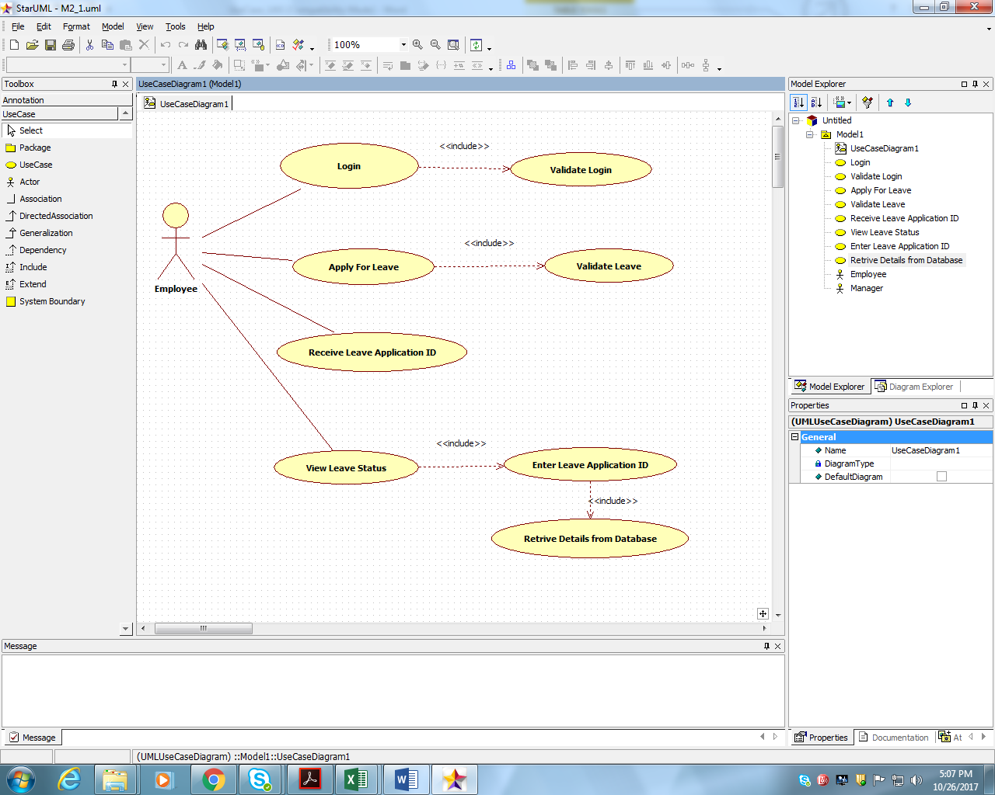

1. Scenarios

* Success Scenarios
* successful sign up to make my journey user registeration form after rejecting the username entered by the user and user successfully signs up.
* Failure Scenarios
* Web Server Down
* Database Connectivity Error
* Network Connectivity Error
* User leaves the **Make My Journey User Registration Form**  blank and click on submit

1. Issues

* What if the user enters invalid Email Id ?

1. UI Specifications

<< Provide a link to the UI specification document of the Use case. Please don’t embed the document here>>

1. Inter System Dependencies

**Module: ‘Make My Journey User Registration Form**  ’ gets impacted due to :

Use case name: Alternate Flow 2

**Impact**: If the user tries to Submit without entering the mandatory fields, he should be denied to do so.

1. Integration with an already existing System of the <<Customer>>

<< This is especially applicable if the project at hand is an enhancement to an existing system.>>

1. Assumptions

<< List down all the assumptions considered by this use case>>

REVISION HISTORY OF THE WORK PRODUCT

<to be maintained by projects>

|  |  |  |  |  |  |
| --- | --- | --- | --- | --- | --- |
| # | Date | Version # | Section Changed | Details of changes made | Approved By |
| 1 |  |  |  |  |  |
| 2 |  |  |  |  |  |